**LINEAR INTEGRATED CIRCUIT AND DESIGN**

**IA2 Simulation based Assignment**

**Sem-Vth (2021-22)**

**Total marks-50**

**Instructions:**

* **Attempt All questions**
* **Even roll number students and Odd roll number students are required to solve the respective numerical mentioned.**

Note:

* In simulation, you are required to put **Roll_no_Name** on schematic .
* Also write **DOP and IA1** on top right side of simulation
* In waveform, Vin(name of student) and Vo(name of student) should be written

**ETRX B1**

**Name: Vedant Kelkar**

**Roll No: 1912052 Marks:**

Q1. Design an Inverting Schmitt Trigger with upper threshold point as + 4.5V and lower threshold point as - 2.5V (Even roll no: Solve this)

Design an Inverting Schmitt Trigger with upper threshold point as + 4V and lower threshold point as - 6V (Odd roll no: Solve this)

Hint: Use Asymmetric design technique with diodes.

Build your designed circuit in LTspice and verify/validate your design values with at least three set of reading’s for the suitable inputs (include one where hysteresis curve disappears) (Attach handwritten solution of design, and printscreen images of schematic & results. Also, prepare observation table for three set of readings)

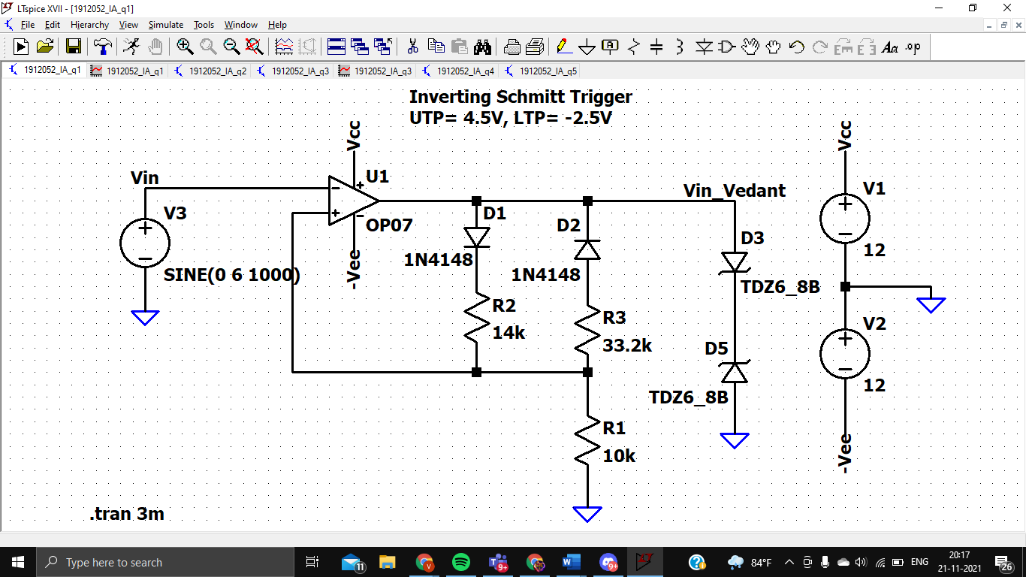

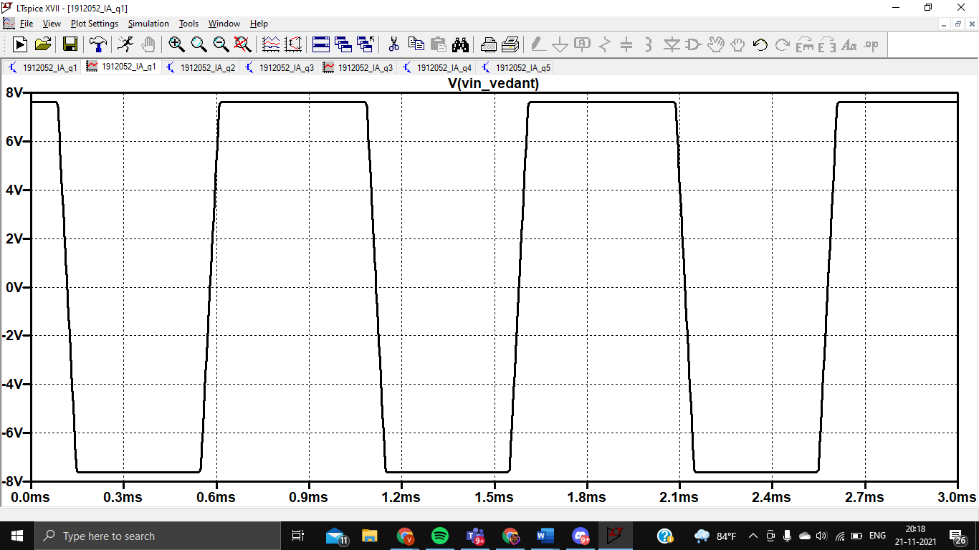

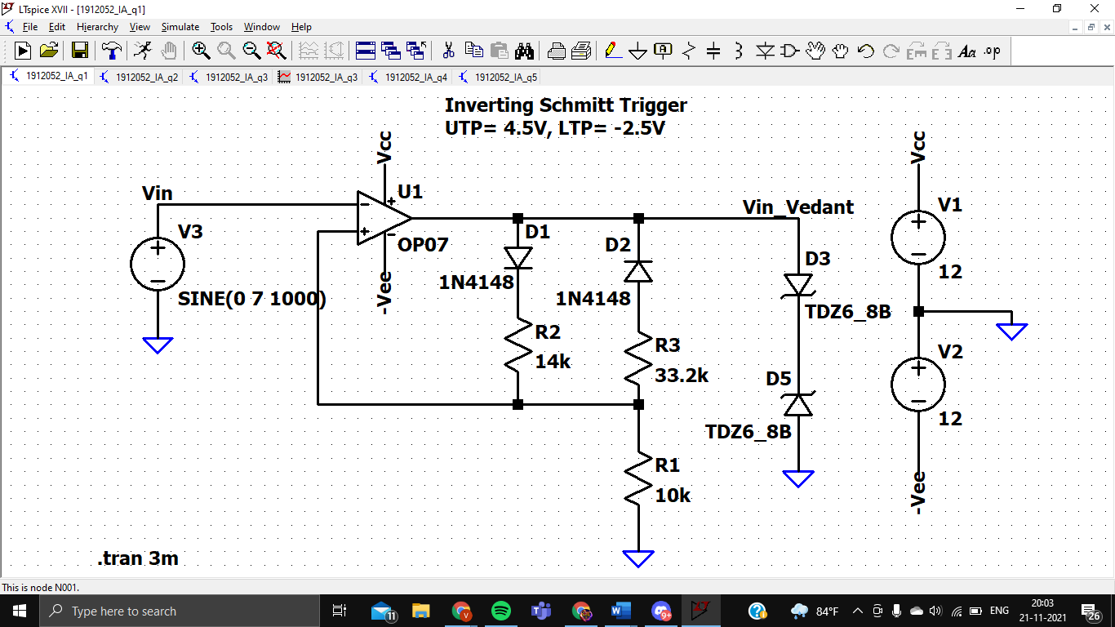

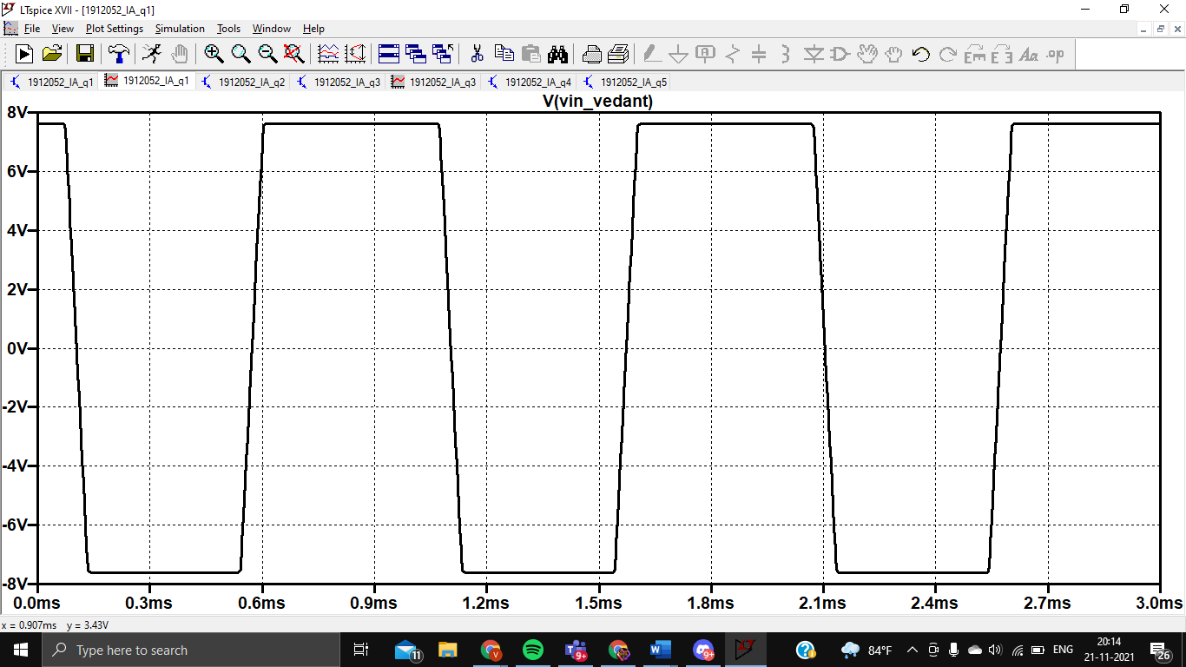

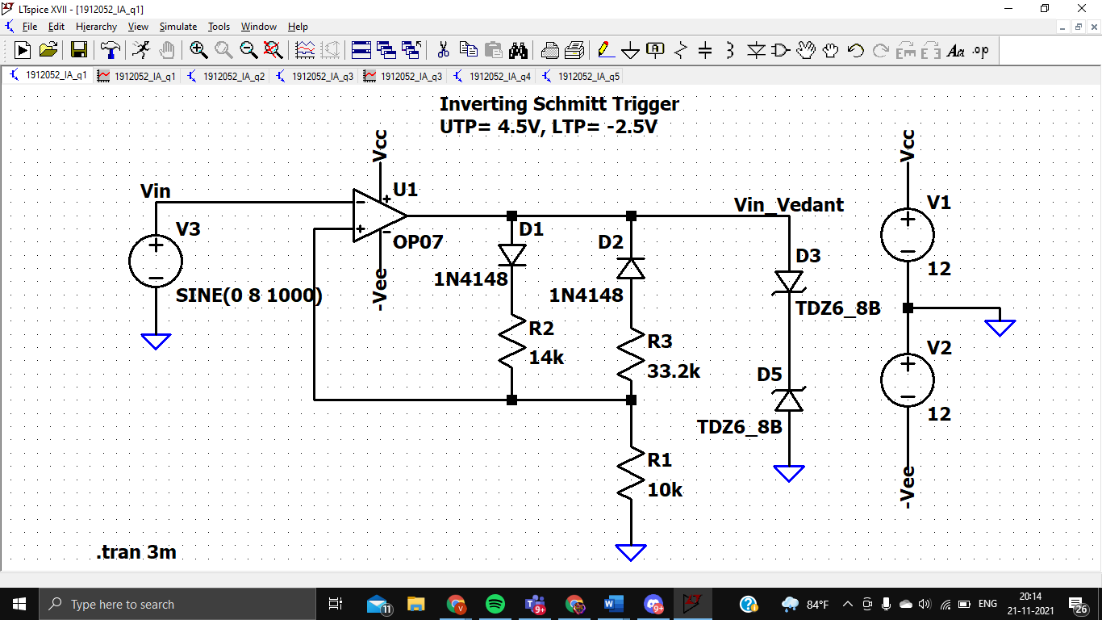

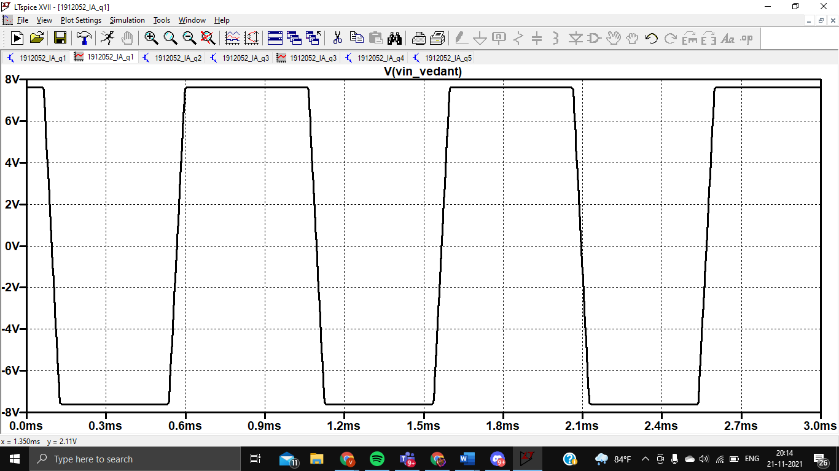

|  |  |  |
| --- | --- | --- |
| Vin | Vutp | Vltp |
| 6V | 4.3V | -2.48V |
| 7V | 3.8V | -2.25V |
| 8V | 4V | -2.5V |

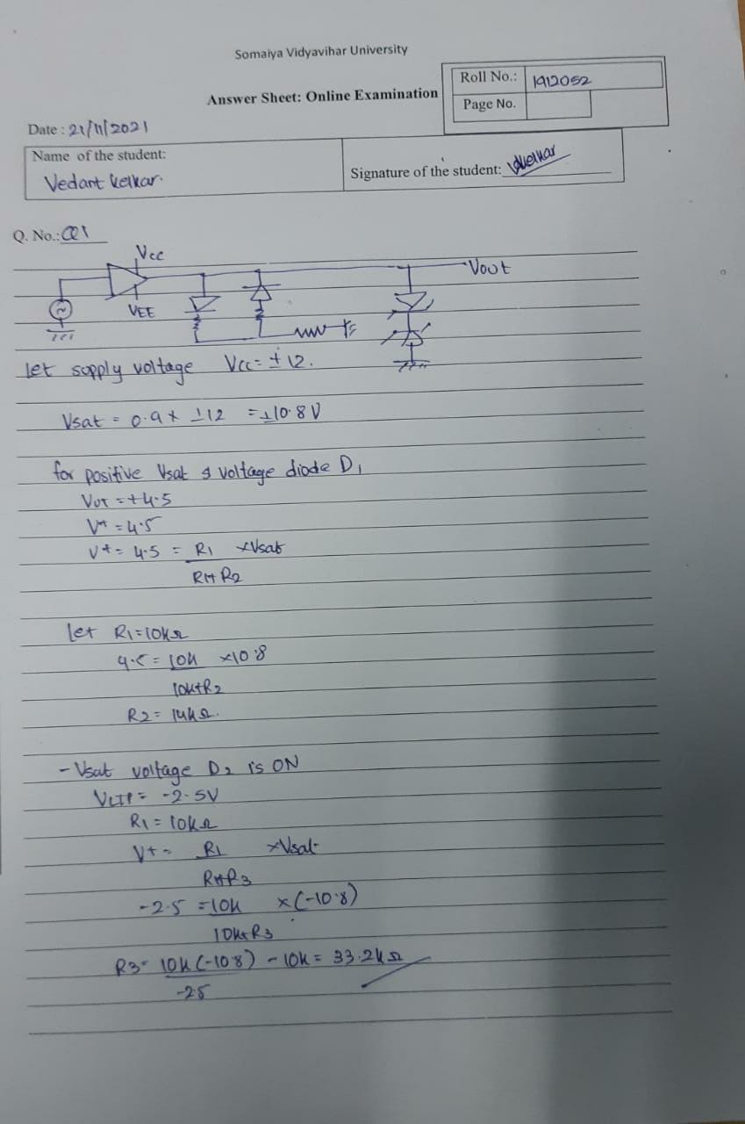

Q1 is for 10 marks, Select suitable Supply voltage to power up the Opamp OP-07

**Q2.** Design an instrumentation amplifier whose gain can be varied in the range of 2 to 2500. **(Odd roll no: Solve this)**

Design an instrumentation amplifier whose gain can be varied in the range of 10 to 1500.

**(EVEN roll no: Solve this)**

**Hint:** Start with 2nd stage design first.

Build your designed circuit in LTspice and verify/validate your design values with at least three set of reading’s for the **suitable** inputs. (Attach handwritten solution of design, and printscreen images of schematic & results. Also, prepare observation table for three set of readings)

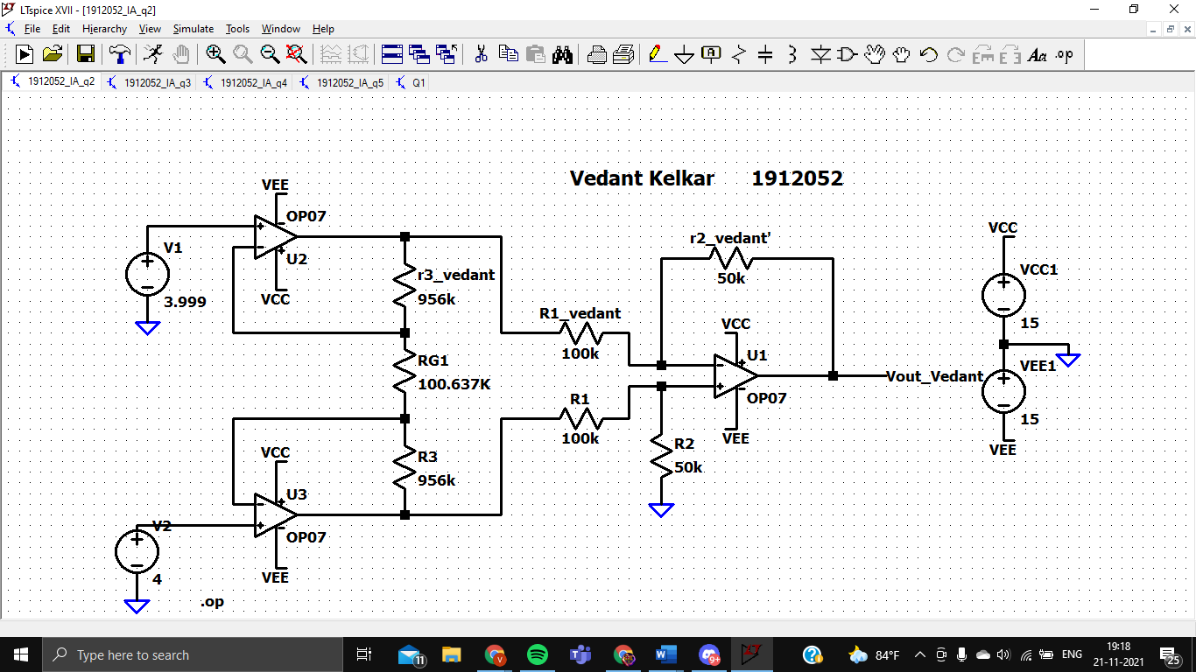

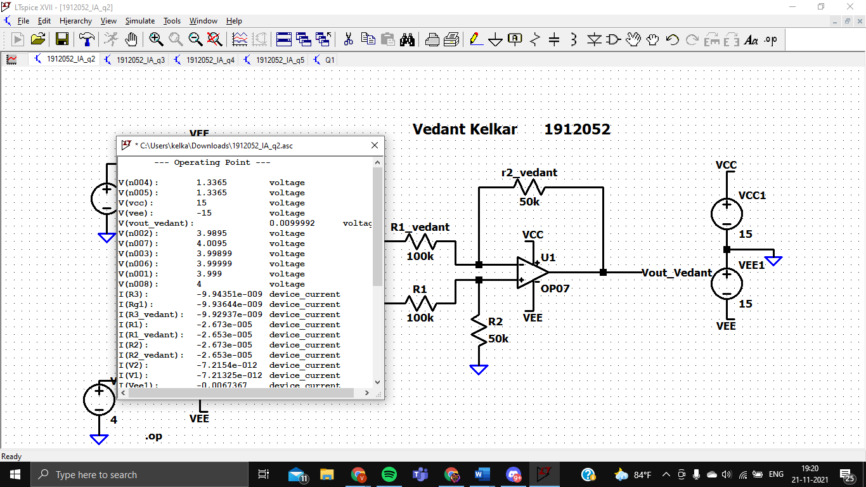

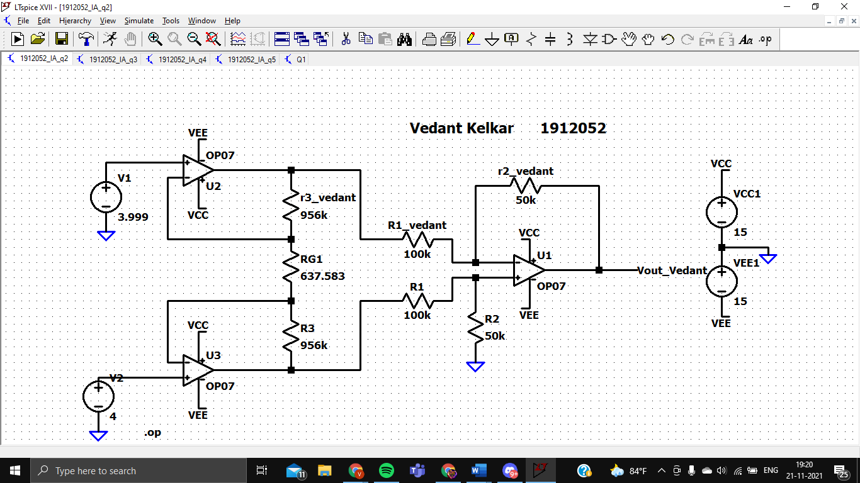

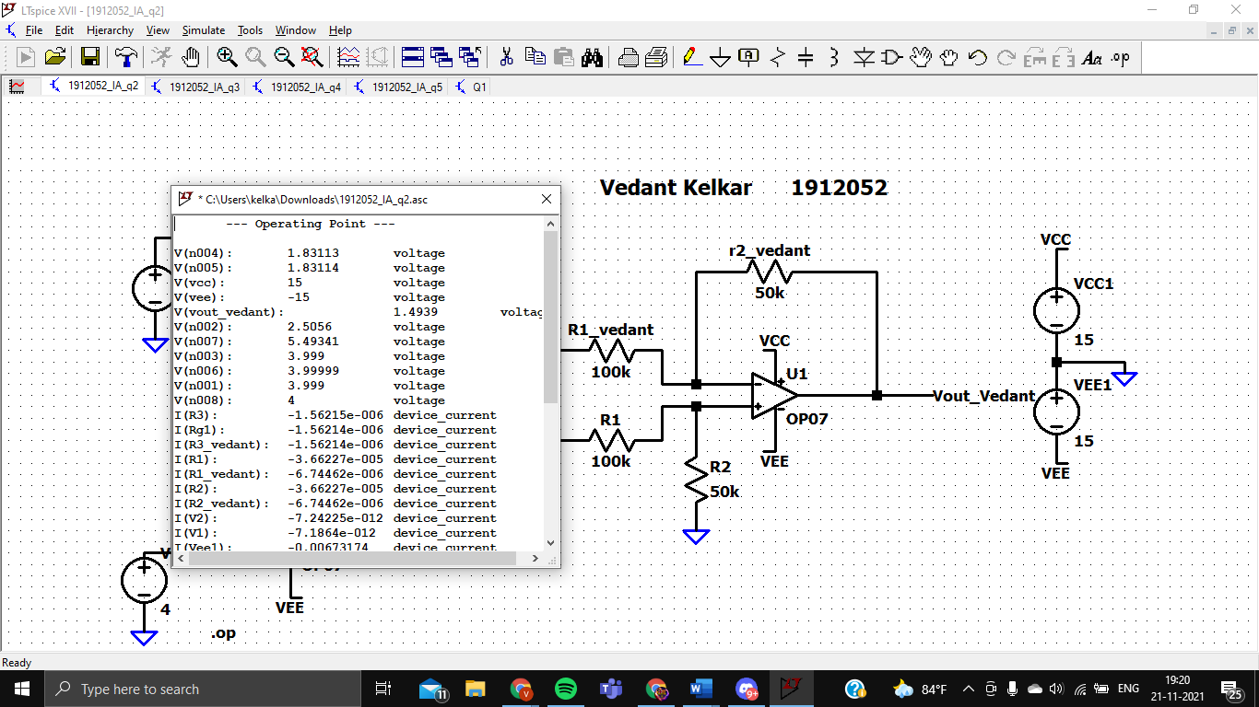

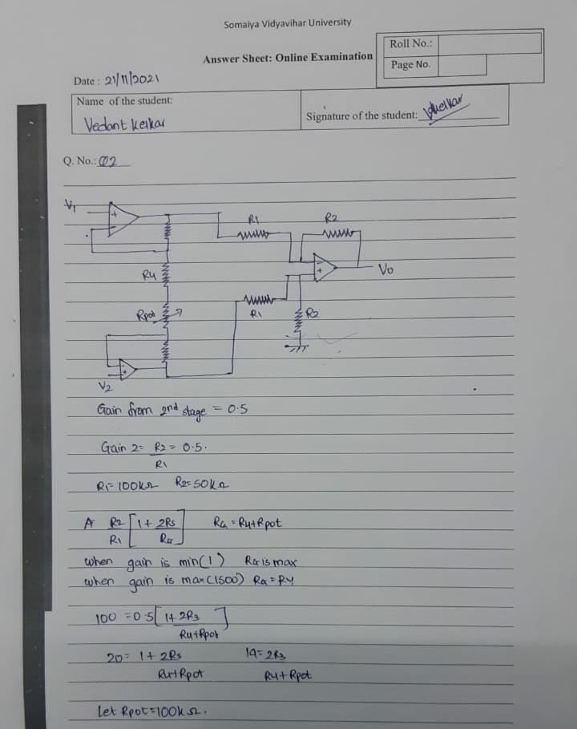

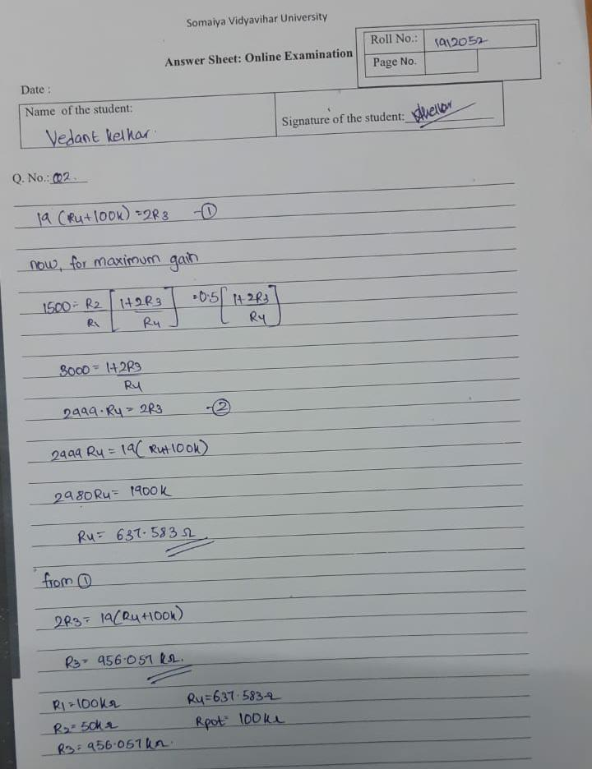

Q2 is for 10 marks, Supply voltage can be ±15 V to power up the Opamp OP-07

**Q3.** .Design an non-inverting amplifier for a gain of 15, and with an input impedance of 1.2MΩ **(For Even Roll Numbers)**

1.Design an inverting amplifier for a gain of -9, and with an input impedance of 15kΩ

**(For ODD Roll Numbers)**

a to d part remains same for the above question:

1. Build your designed circuit in LTspice and verify your design values. (One can max Vin = 200mV peak sine wave, f = 1500 Hz
2. Increase Vin to 2.5V peak, keeping frequency same and observe the output waveforms. Record the peak values of output waveforms. Comment on the output obtained.
3. Increase f to 30 KHz , keeping Vin = 200mV peak and observe the output waveforms. Record the peak values of output waveforms. Comment on the output obtained.
4. In a), perform parametric sweep on any one external resistor and obtain 5 simultaneous outputs visible at the same time.

A

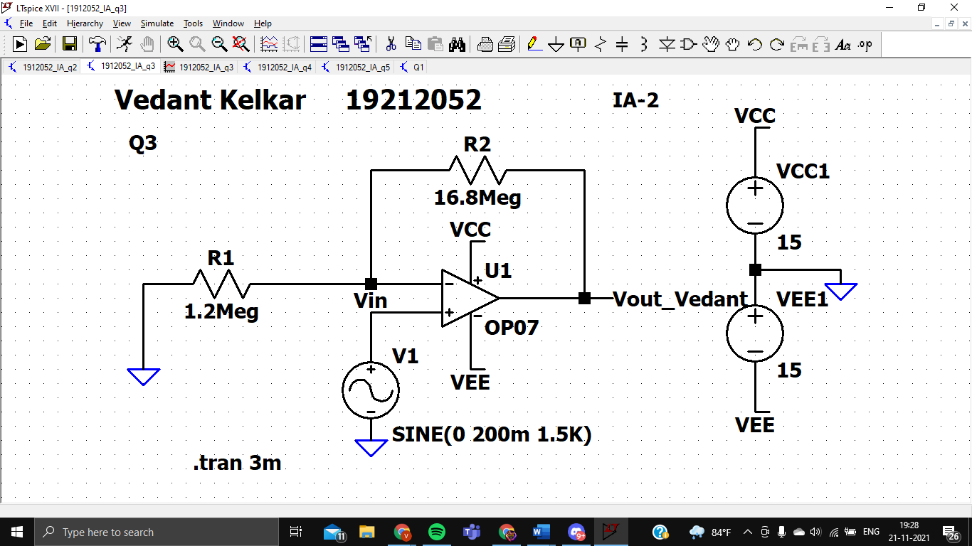

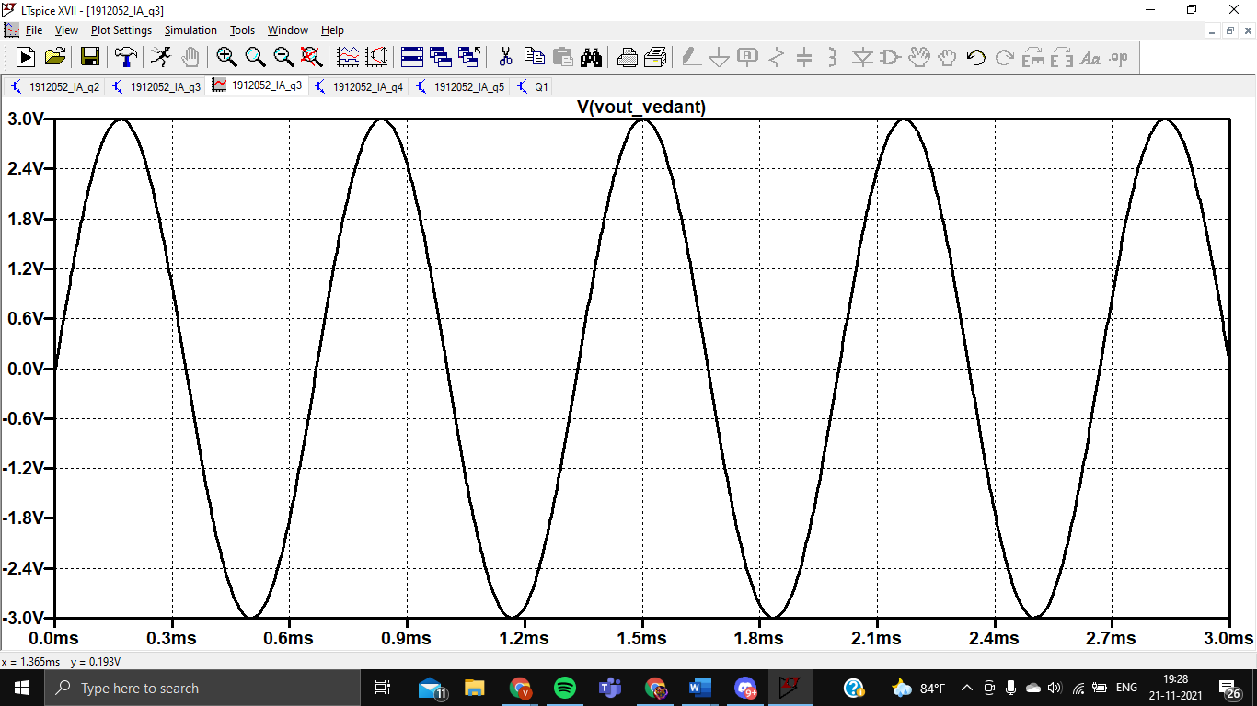

B

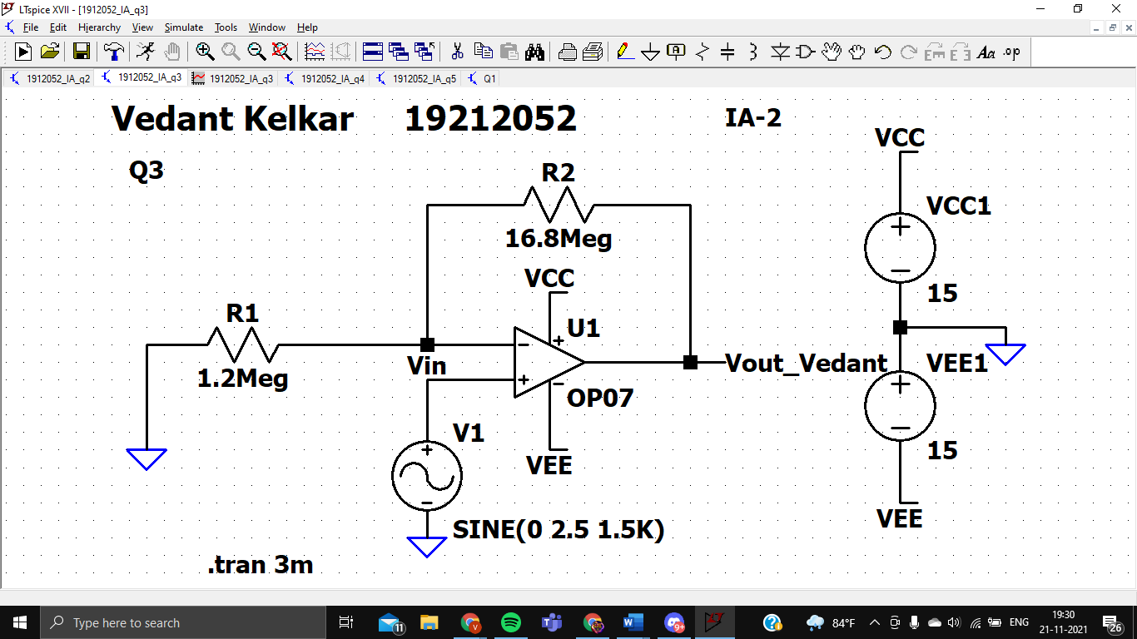

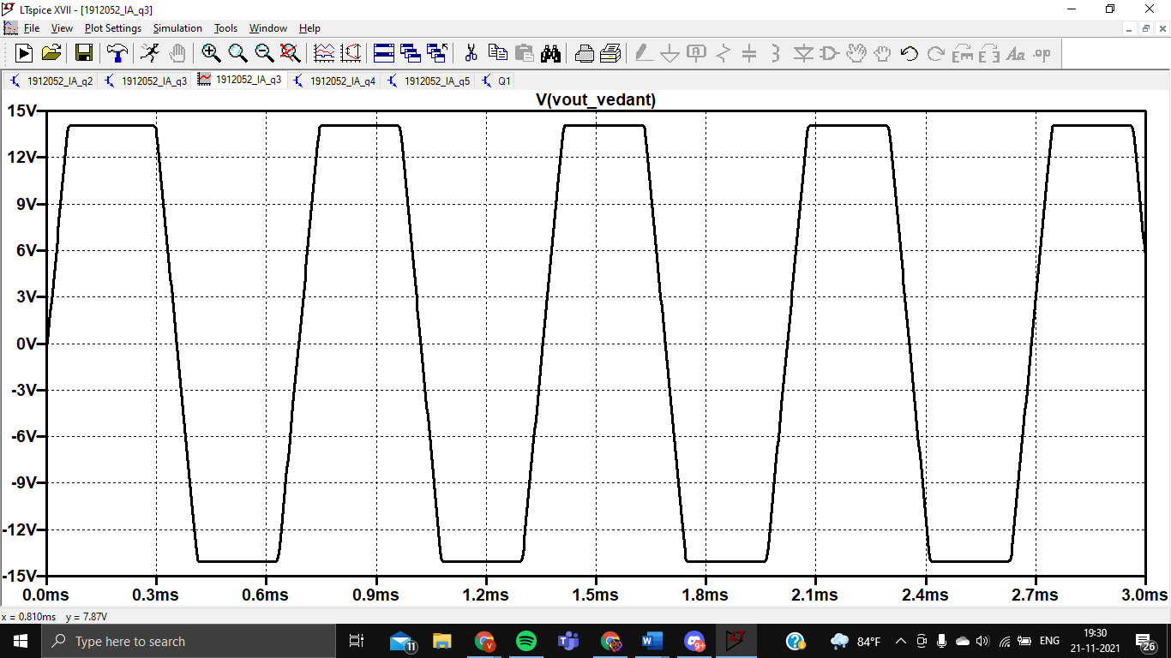

As we can see the output, the waveform of the out gets cut at around +/-14V which is nothing but the Saturation voltage of the Op-Amp.

C

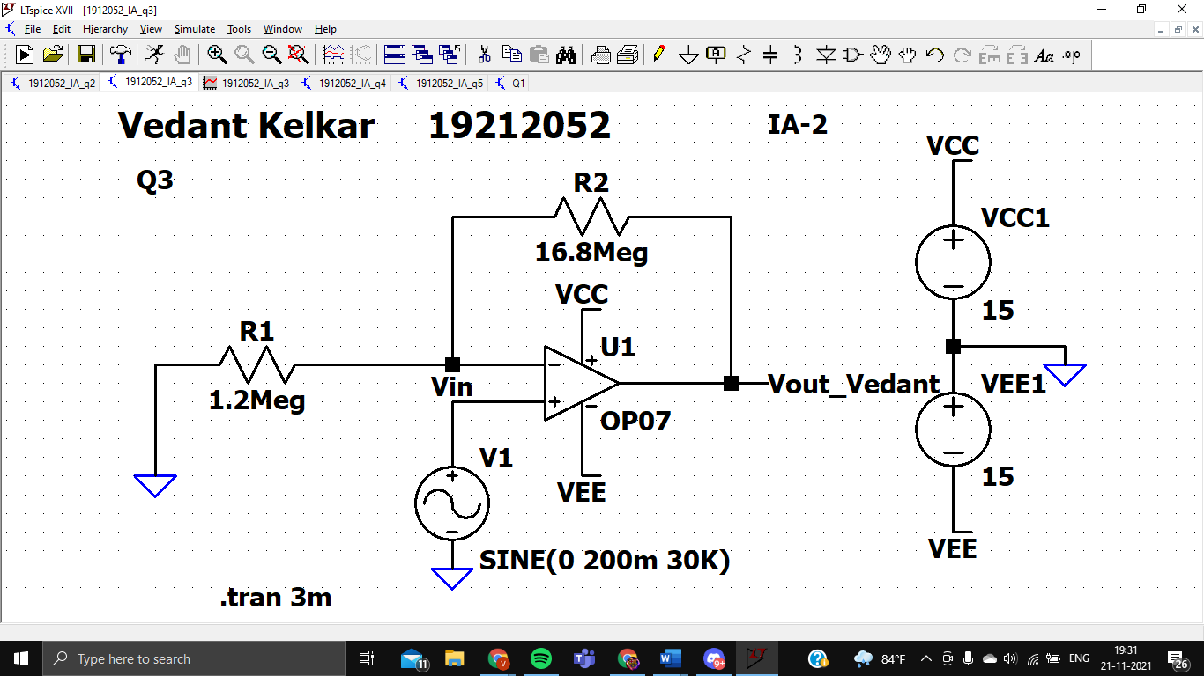

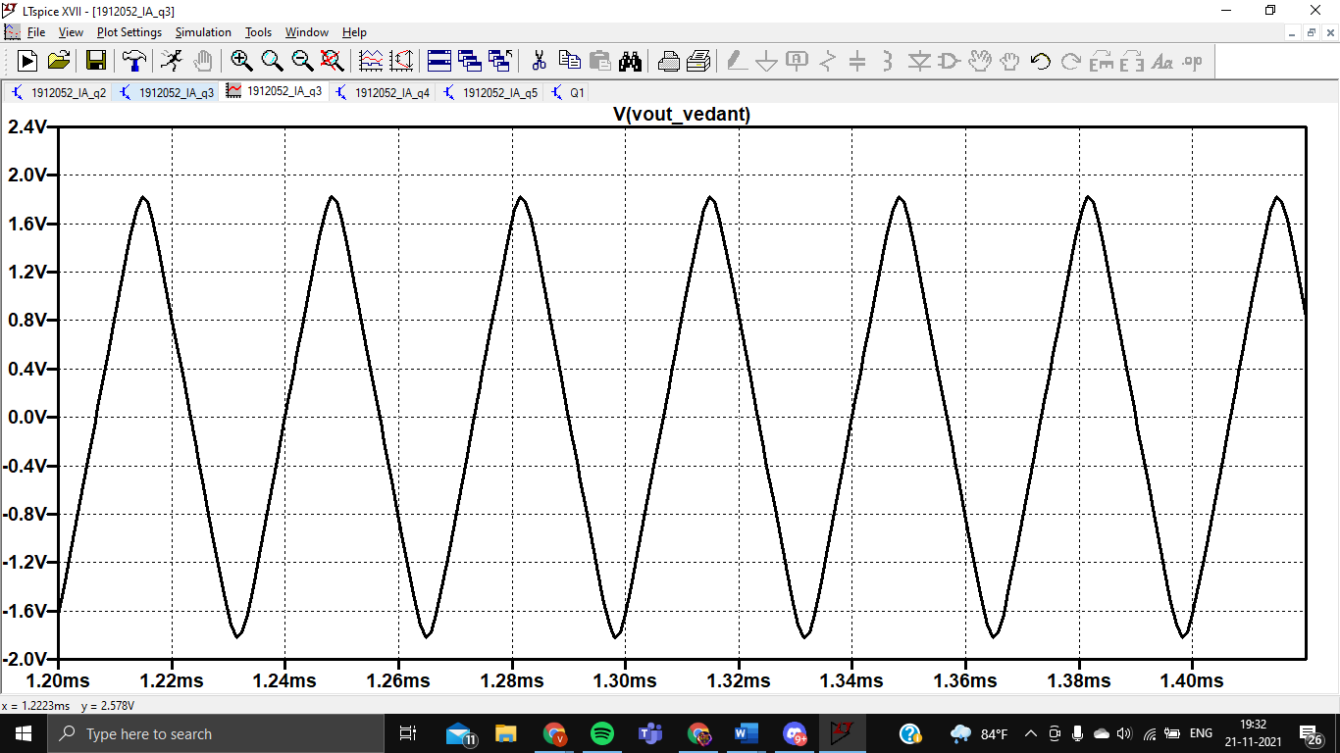

As we can see the output, the number of peaks per unit time increases as we increase the frequency

D

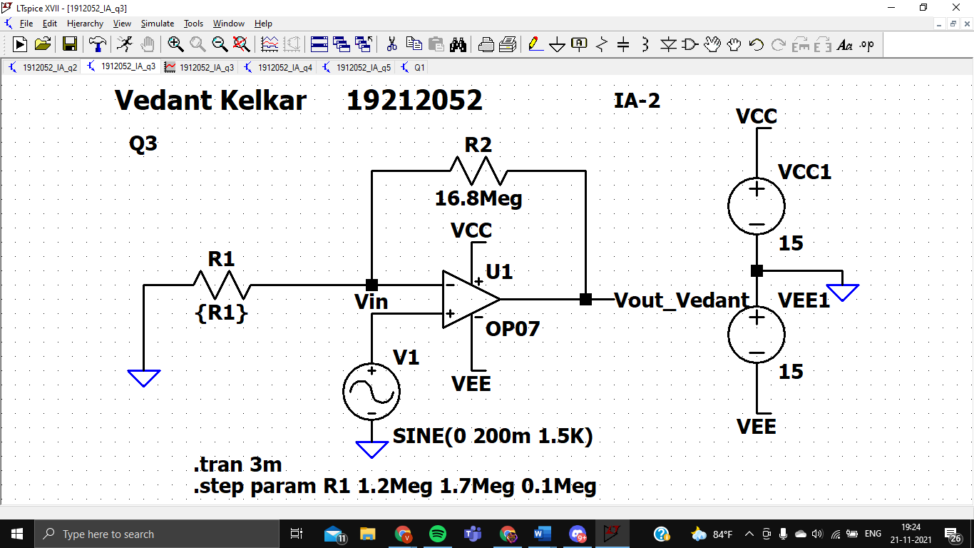

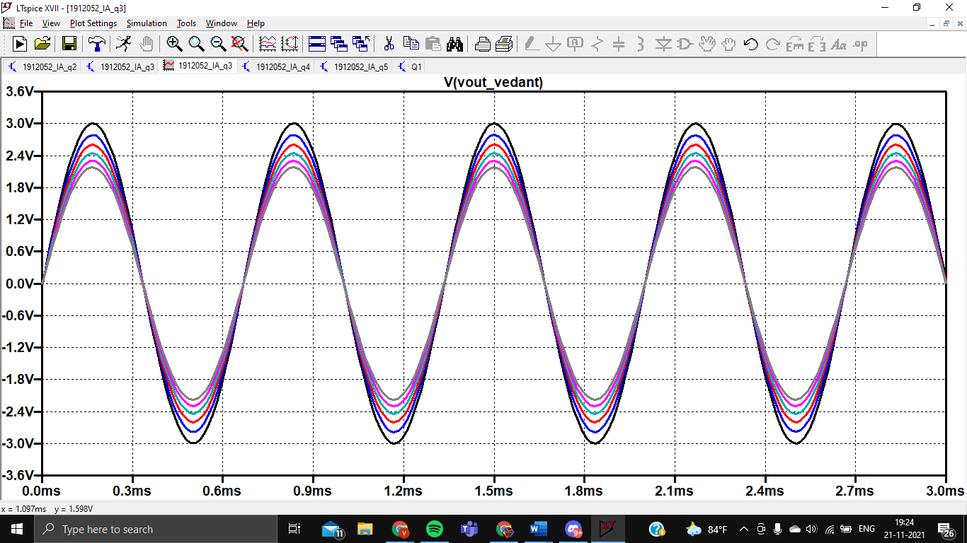

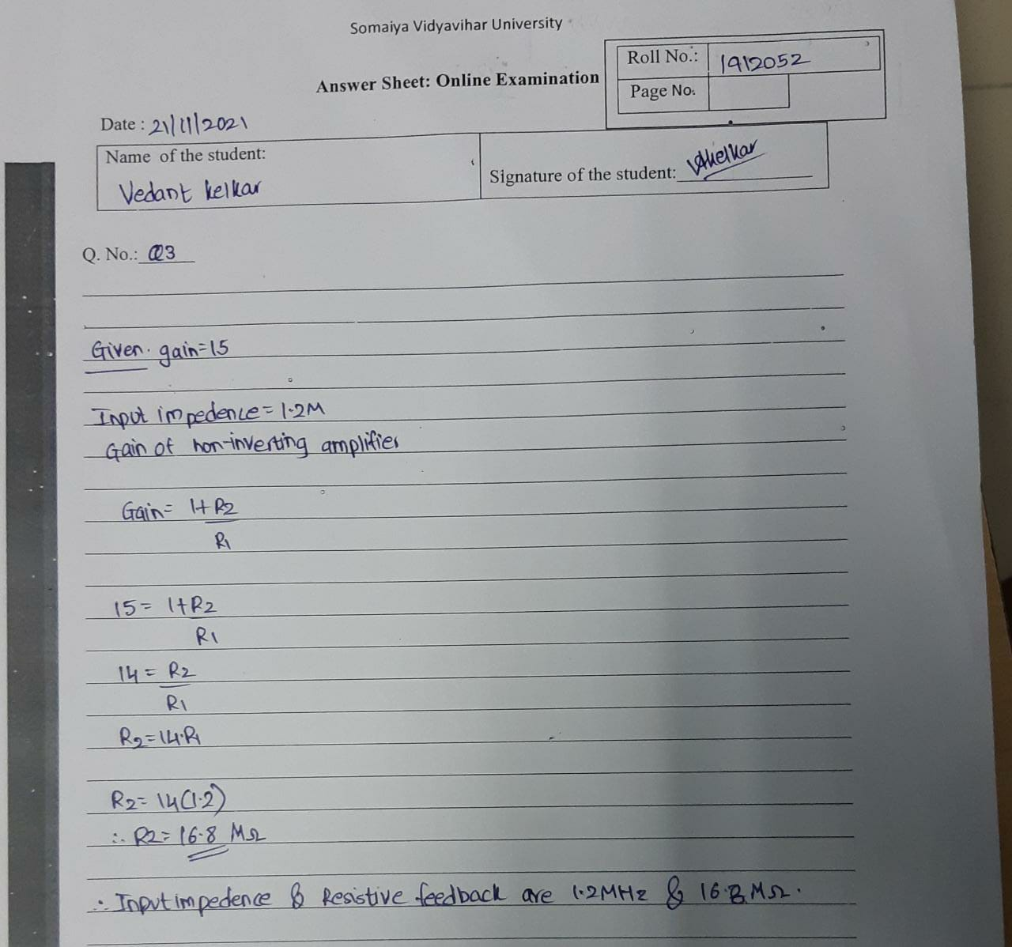

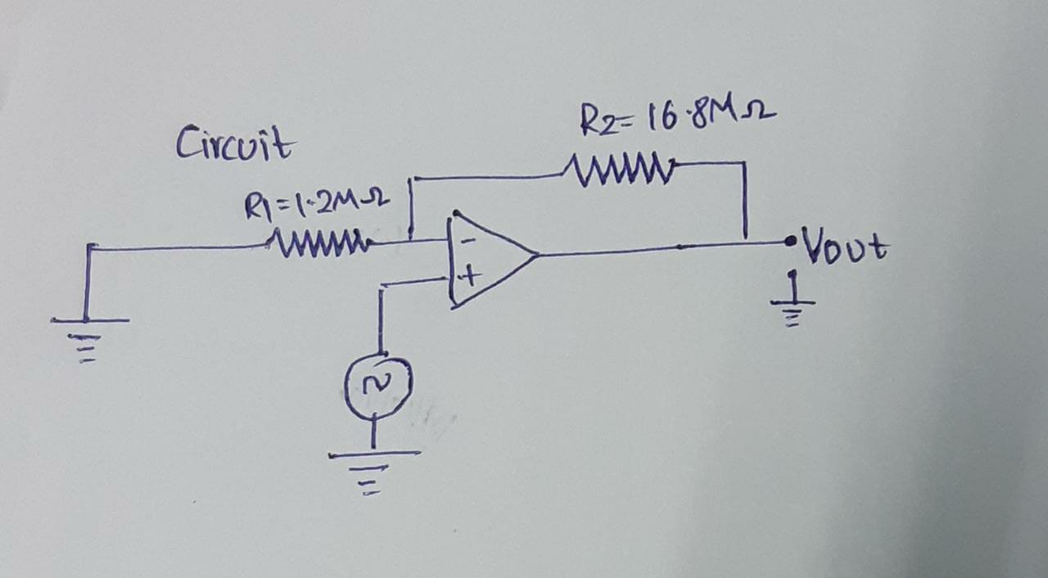

Q3 is for 10 marks, Supply voltage can be ±15 V to power up the Opamp OP-07

**Q4.** Design a summing amplifier to add three input voltages. The output of this circuit must be equal to 4 times the negative sum of the inputs.

Build your designed circuit in LTspice and verify/validate your design values with at least three set of reading for the inputs. (Attach handwritten solution of design, and printscreen images of schematic & results. Also, prepare observation table for three set of readings)

Q4 is for 10 marks, Supply voltage can be ±15 V to power up the Opamp OP-07

**(For all students**)

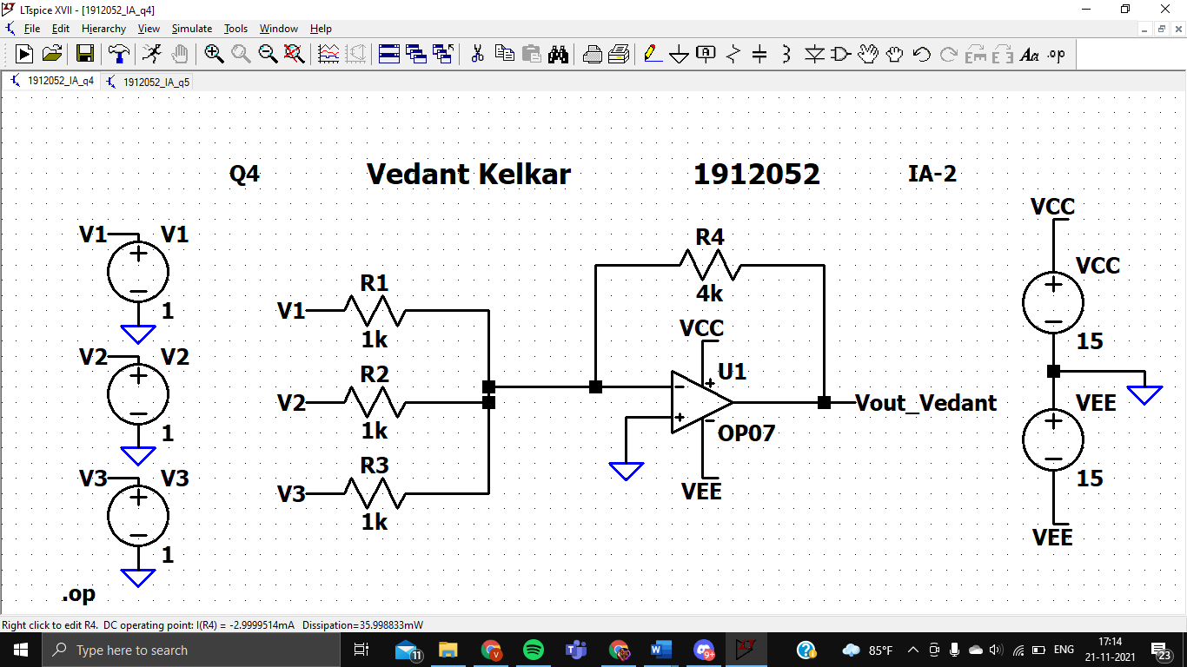

1st reading

Vout=-9.99982V

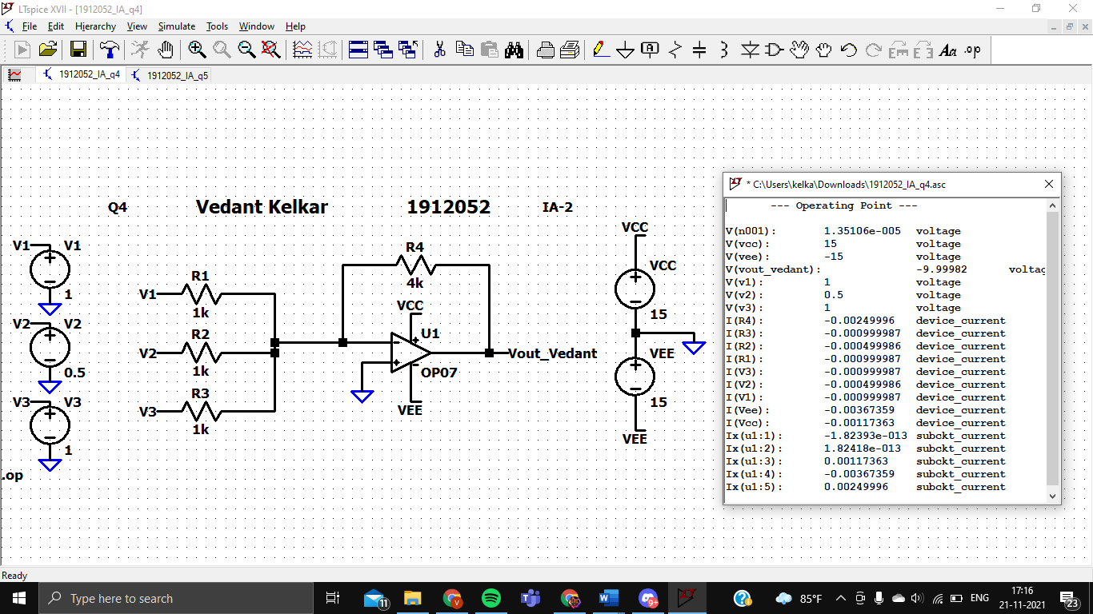

2nd reading

Vout=-7.99986V

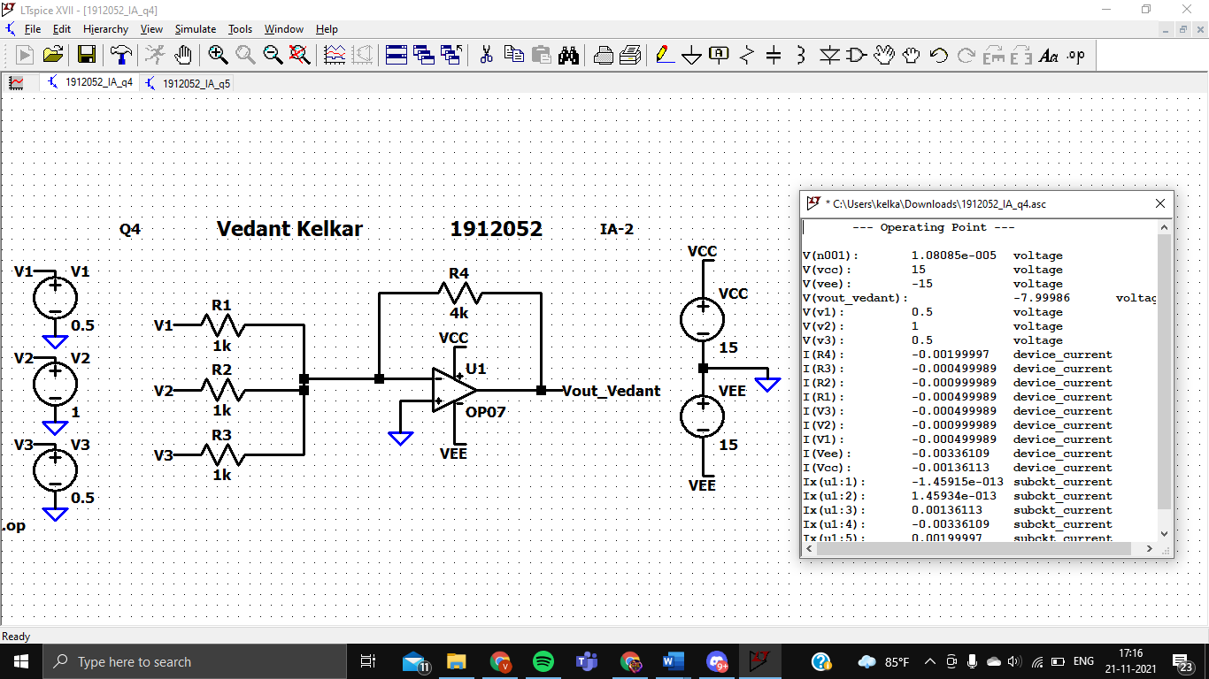

3rd reading

Vout= -11.9998V

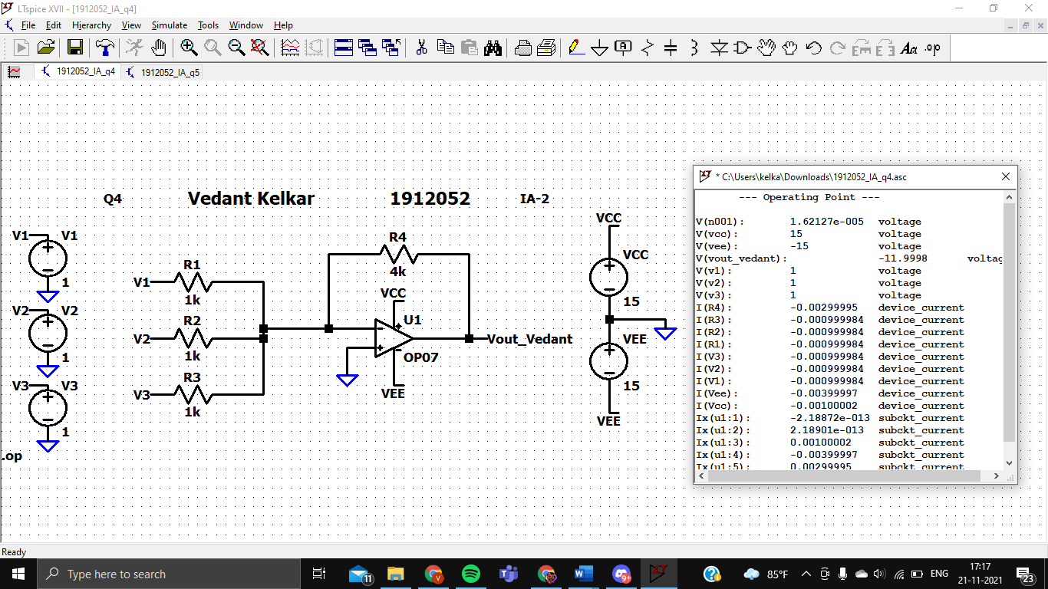

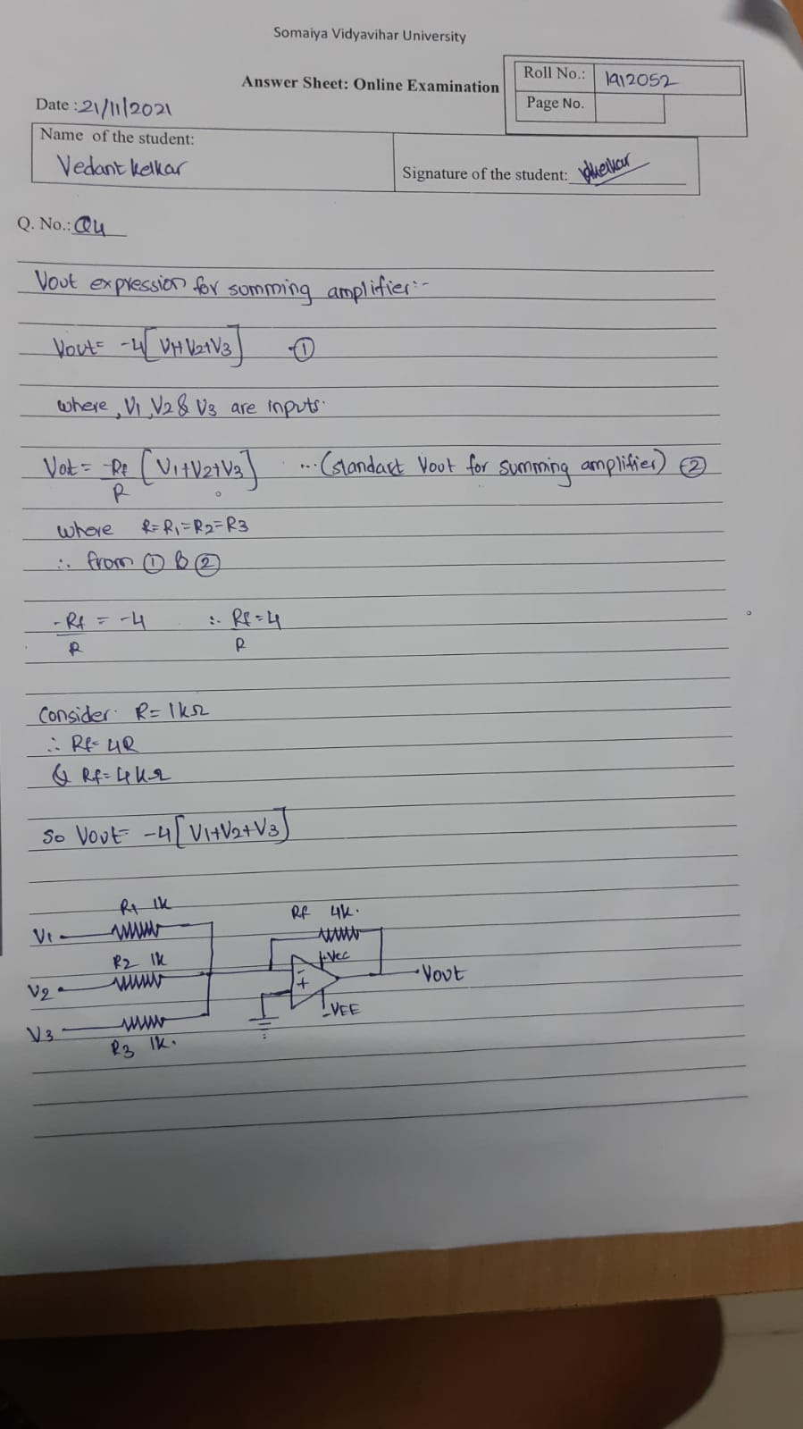

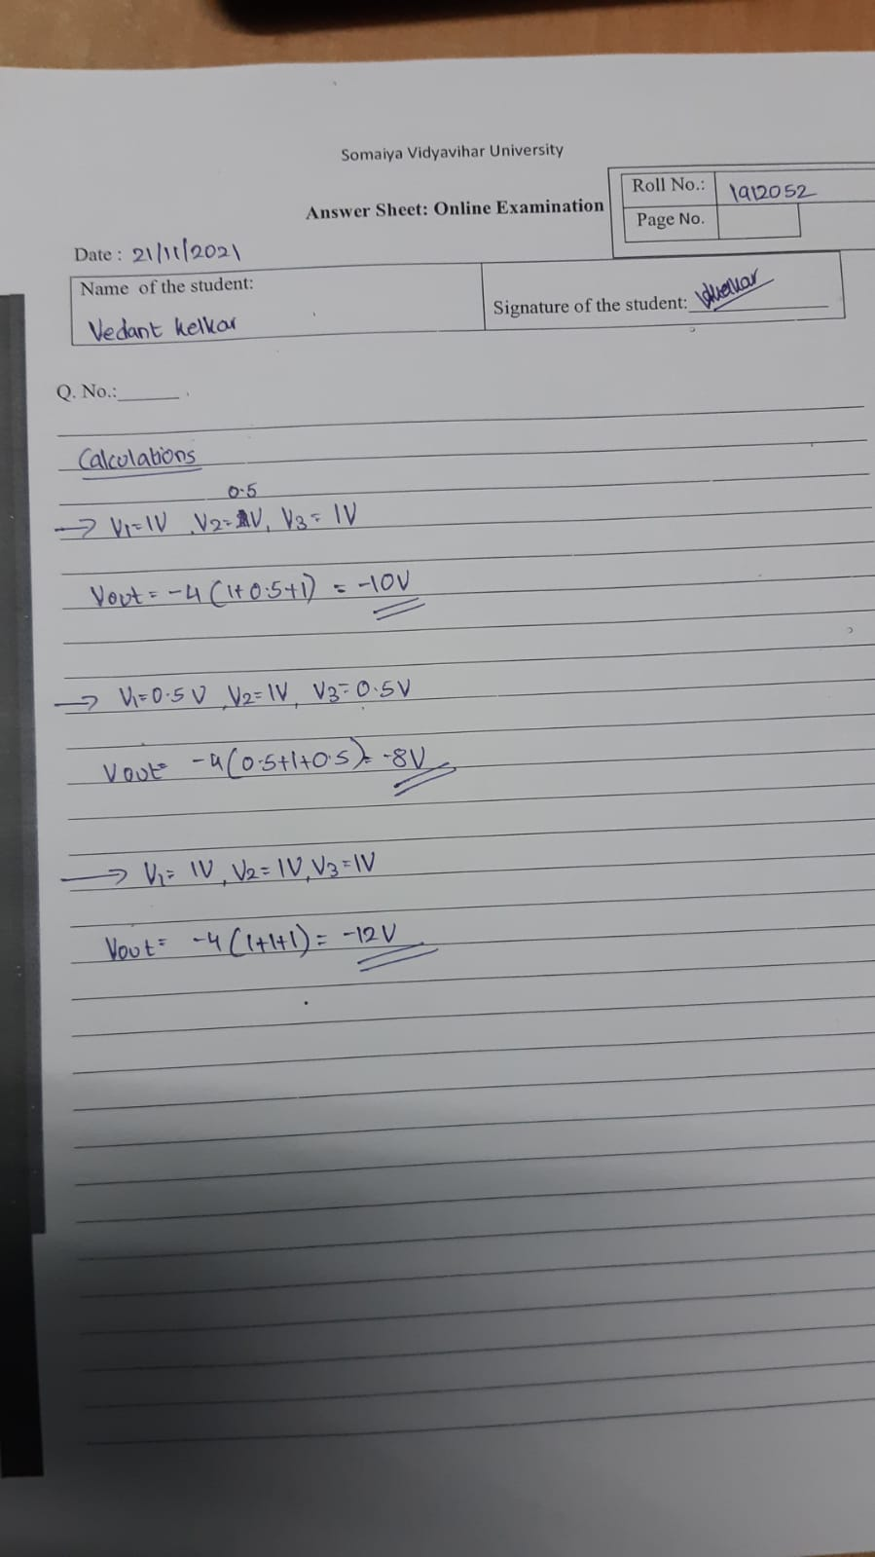

**Q5.** Find $V_{0}$ for the adder-subtractor circuit shown .  **(For all students)**

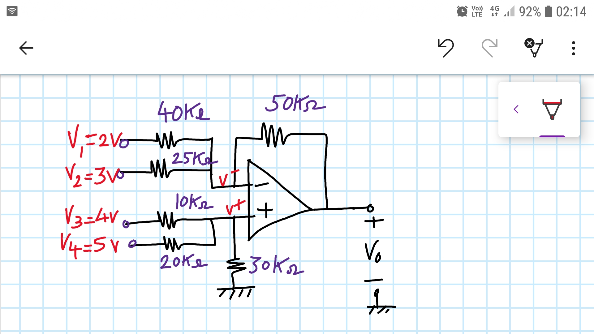

Build your designed circuit in LTspice and verify/validate your design values. (Attach handwritten solution of design, and printscreen images of schematic & results)

Q5 is for 10 points, Supply voltage can be ±15 V to power up the Opamp OP-07

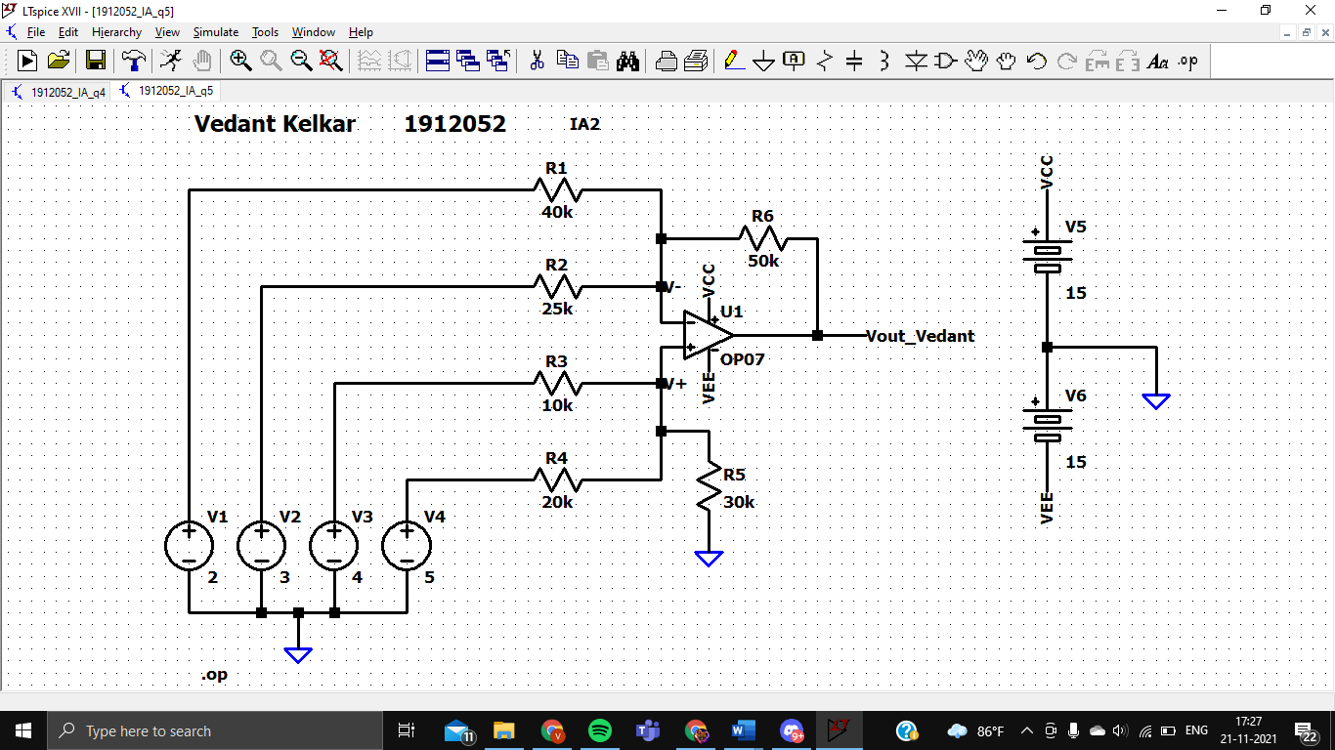

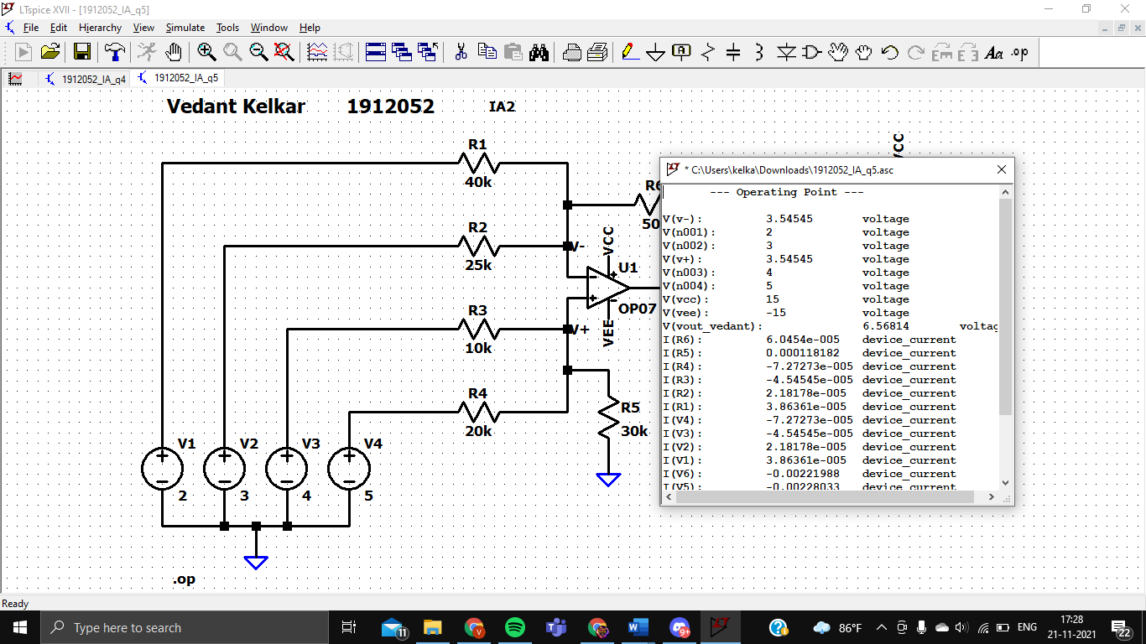

Vout= **6.56814 V (simulated)**

